

Department | FED
Subject | DSA-2
Academic Year | I-III Semester(2025-26)
Faculty Name | Gopi Krishna
Student Name | V Sri Bhargavi
Roll Number | 2520040048
Branch | ECE
Course Outcome | 1

Case Study Topic: Bank Transaction Range Query System using B+ Tree

Work Done Summary:

In this case study, we implemented a B+ Tree of order 4 to index bank transaction amounts.
The purpose was to efficiently retrieve all transactions within a given amount range.
We inserted 25 mixed transaction values and observed node splitting and promotions.
Leaf-level linked list traversal was used to return continuous data blocks quickly.

Implementation Details:
- Constructed a B+ Tree with max 3 keys per node.
- Inserted transactions in random order to test overflow and node splitting.
- Observed internal node promotions during multiple splits.
- Implemented RangeQuery(x, y) using leaf-node chaining.
- Compared performance with BST and linear search.
- Concluded B+ Tree gives superior range-query performance due to linked leaves.
Result: Screenshots :
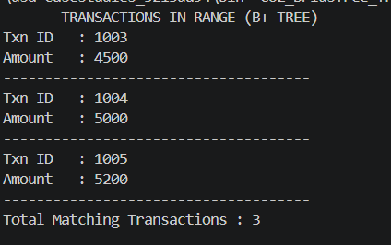
The B+ Tree successfully handled range-based transaction queries efficiently.
For the selected range (1003 – 1005), the following transactions were returned:
1003 → ₹4500, 1004 → ₹5000, 1005 → ₹5200
Time Complexity:
• Insertion: O(log n)
• Range Query: O(k + log n)

GitHub Link: https://github.com/sribhargavivaddavalli-svg/DSA_CASESTUDIES

